 | Using TechNoir Transmissions to play The Veil  This document outlines a method to use a Transmission from TechNoir when playing The Veil. The right hand side of the page is a worked example. |  |  | 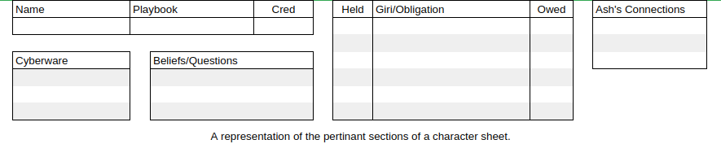
 | 1. Create characters according The Veil, with the following exceptions:  - Don't give PCs any cyberware  - Each PC receives 1 extra Cred on top of what's specified in The Veil rules  - Don't complete PC Beliefs/Questions |  |  | 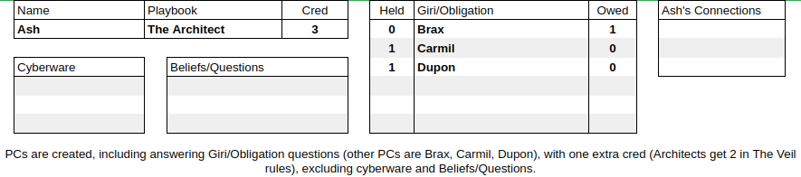
 | 2. Players select 3 Connections from the Transmission as per TN rules (p20) |  |  | 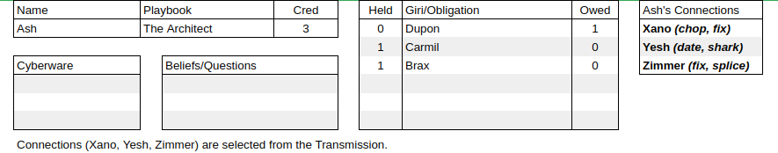
 | 3. Assign relationship adjectives as per TN rules (p22), and give each PC and their Connections get 1 Giri/Obligation on each other. |  |  | 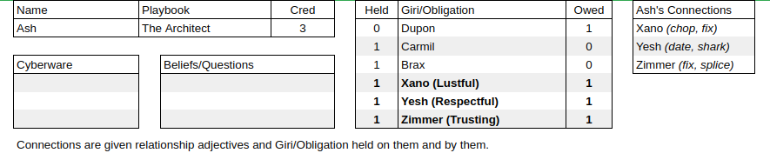
 | 4. Players spend PC cred on gear or installing cyberwear, if they wish.  - Unlike in The Veil rules, during character generation each piece of cyberwear costs 2 cred to be installed. |  |  | 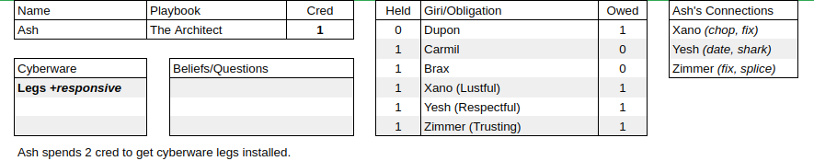
 | 5. Favours from Connections are called in, as per TN rules (p39,58).  - See the modified Favours (based on TN p39) below. |  |  | 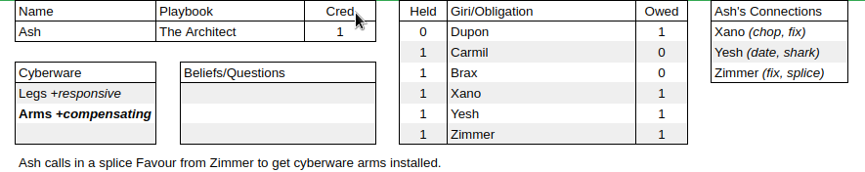
 | 6. Take turns creating Beliefs/Questions as per The Veil rules. |  |  | 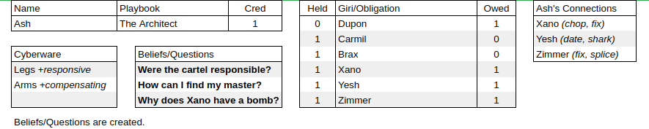
 | Notes  - It’s suggested that you ignore The Veil rule that requires every player to use the Link move at least once in the first session. Also, probably avoid allowing the Link move to be used to create additional Connections (PCs who will always, when leaned on, automatically provide beneficial information even without dice being rolled) unless replacing dead Connections.  - The exchange rate used from TechNoir Kred to The Veil Cred here is: 40% rounded up (minimum 1).  - The extra Cred given at character creation above what The Veil rules specify is to offset the fact that cybernetics must have their installation paid for during character creation. Further cybernetics can be installed during character creation via the Splice Favour. |  |  | Favours, slightly modified for The Veil  - Chop: Sell you a stolen vehicle at an 4 Cred discount or buy a stolen vehicle from you at a 4 Cred discount. Tag the vehicle +stolen  - Date: Attend a function with you, getting you access somewhere you wouldn’t be welcome otherwise.  - Deal: Provide a dose of drugs, chemical or digital, 1 Cred.  - Fence: Buy a bulk load of stolen merchandise from you for 2 Cred.  - Fix: Sell you up to three gear of the type they specialise in (e.g. weapons), each discounted by 1 Cred. The discount may make them free. Tag the gear +stolen  - Ride: Transport you, a friend, or illicit goods to a destination inside or just out of the city.  - Shark: Lend you 4 Cred, expecting repayment. Make note that a debt is owed to this Connection.  - Splice: Install a cybernetic object (or an object with the +implanted tag) for free.
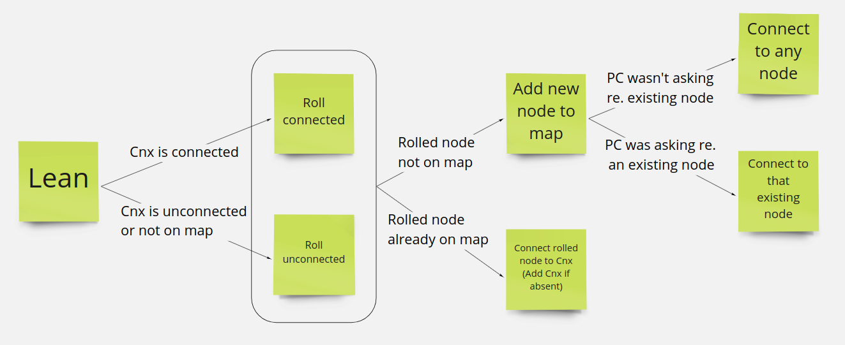
Leaning on a Connection:

